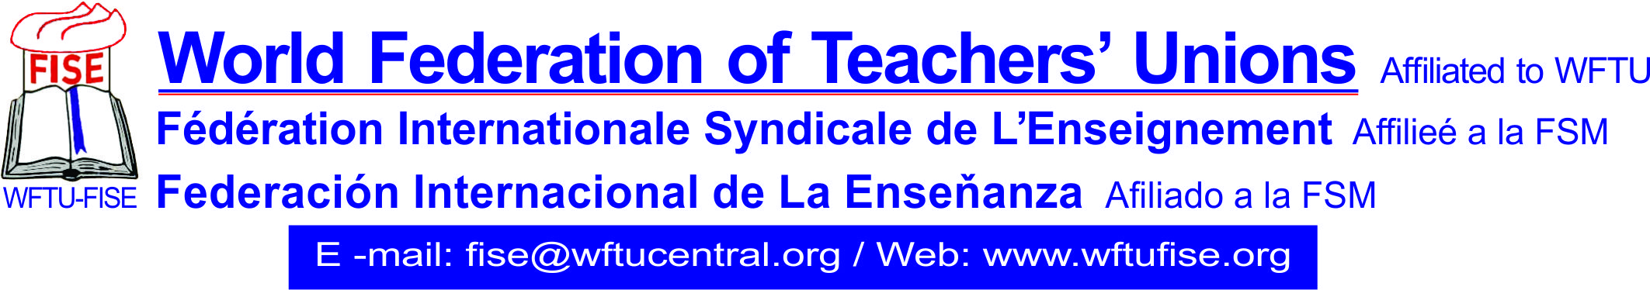
January 11th, 2019
Fierce strike against the protesting teachers by the greek government of SYRIZA-ANEL!
The World Federation of Teachers Unions FISE, member of WFTU (World Federation of Trade Unions), condemns the fierce attack of police force with the use of chemicals and flash-bangs against teachers in Greec, who have started their strike on the 11th of January 2019 and were protesting outside the greek parlament.
The government reinstatement forces injured on the head the teacher and syndicalist in the Teacher Federation and executive of PAME, Drimala Theodora, the teacher and MP for KKE, Delis Giannis and a student of the Philosophics Department, in the University of Athens.
This action is being registered as yet another act of autarchy and barbarism from the government of SYRIZA-ANEL, so that its policy against the people can be passed.
The continuous massive demonstrations of the teachers and the students in Greece are being organised as opposition to the bill regarding the hirings, announced by the government of SYRIZA-ANEL, which is aiming to force thousands of teachers to unemployment and to strike their right to permanent and stable employment.
The teachers demand the uncovered positions in Education covered and the permanent employment of the 30.000 replacement teachers, who have been working with elastic labor contracts.
FISE supports the demonstrations of the teachers and their demands, so that noone gets fired, the replacement teachers get hired permantly, as they have been working for some years now in the schools; so that everyone can have a permanent and stable working position!
We send you a message of solidarity and wish best of luck with your struggle!

THE SECRETARIAT

